**UC 005—Play first level**

**System displays level select menu (Unity Behavior)**

**Player selects level**Call Unity’s load level function from inside level manager class for both the loading screen and the level to be loaded

**System displays a loading screen until level is loaded (Unity Behavior)**

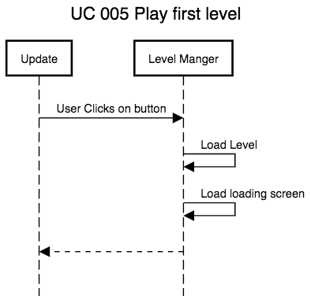

**UC 006—Back to main menu**

**System displays level select Menu (Unity Behavior)**

**Player selects Go back to main menu**

Hides level select UI. And turns on the main menu UI.

**System displays the main menu (Unity Behavior)**

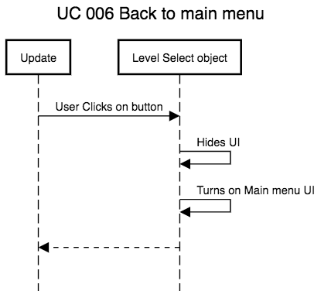

**UC 010—Main menu settings**

**Open settings Menu (Unity Behavior)**  
Hides main menu UI and turns on settings menu UI

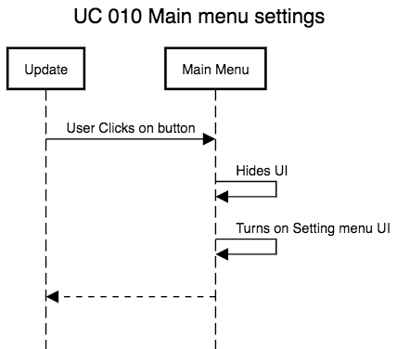

**UC 011—Quit Game**

**Shut down the game (Unity Behavior)**  
Call Unity’s Application Quit function from level manager.

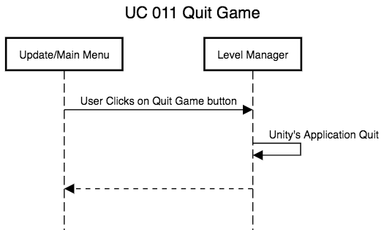

**UC 015—(Adds)Settings menu**

**Show settings menu (Unity Behavior)**

**Show a UI list of editable settings**  
Get editable settings from settings class

**Exit settings when user is done**  
Hide setting menu reopen previous menu

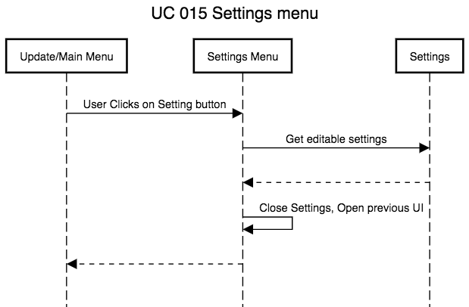

**UC 020—** **In-Game menu**

**Pauses game**  
Call Level Manager Pause Level

Save game time  
 Set game time scale to zero

**System displays in-game menu (Unity Behavior)**  
Turns on in-game menu UI

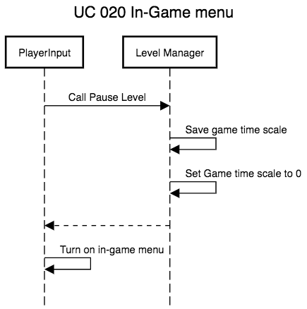

**UC 022—Resume Game**

**Close in-game menu**

Hide in-game menu UI

**Un-pause game**

Call Level Manager Pause Level

Set game time scale back to what it was previously

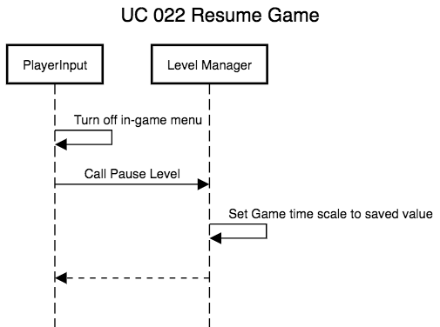

**UC 024—Open Setting menu**

**Open settings menu (Unity Behavior)**  
Hides In-Game UI and turns on settings menu UI

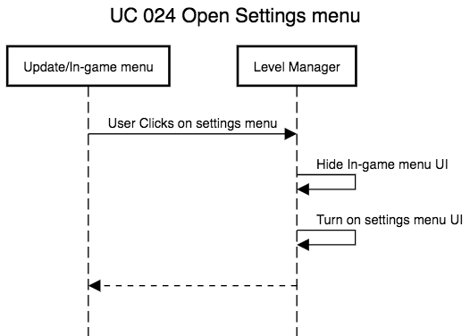

**UC 026—** **Quit Level**

**Close in-game menu**  
Hide in-game UI  
Set game time scale to 1

**Close level**

**Open main menu**  
Call load level from the level Manager for the main menu

**System displays main menu (Unity Behavior)**

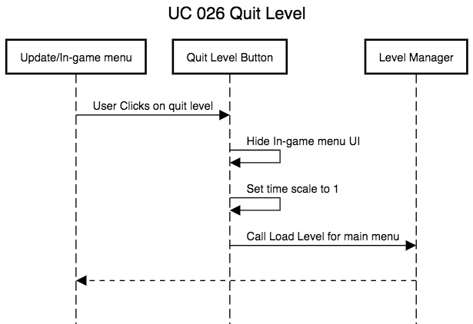

**UC 028—Quit Game from Level**

**Shut down the game (Unity Behavior)**  
Call Unity’s Application Quit function.

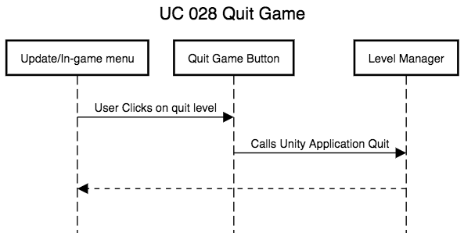

**UC 035—After Level Info**

**The system displays the score that the player got during the level**  
Get all score info from Level Manager

**Allow user to upload his score to the sever**

Connect to the database and send anonymous data about the players score

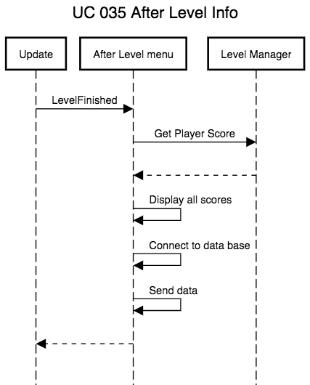

**UC 037—Go to next level**

**Player clicks on next level**  
Call Unity’s load level function from inside level manager class for both the loading screen and the level to be loaded

**System displays a loading screen until level is loaded (Unity Behavior)**

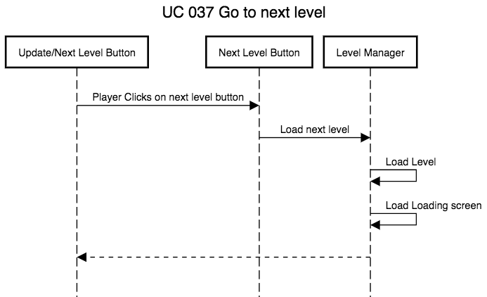

**UC 039—Quit to main menu**

**Close after level menu**  
Hide after level UI

Set game time scale to 1

**Close level**

**Open main menu**  
Call load level from the level Manager for the main menu

**System displays main menu (Unity Behavior)**

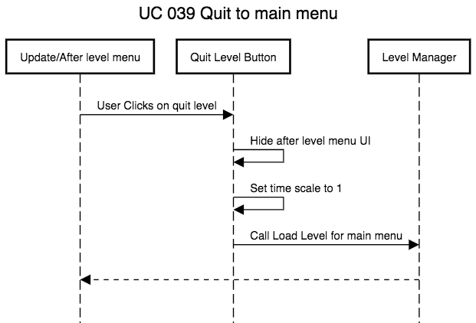

**UC 045—Player looking**

**Take input from mouse to look around**  
Inside Player Interaction’s Handle Players Input function, translate mouse movement to rotate the players camera around

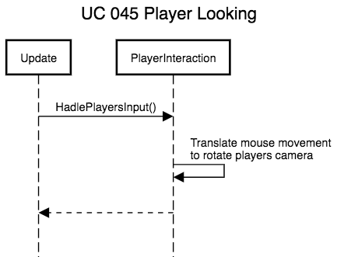

**UC 046—** **Player Movement**

**Read keyboard input to move the player**  
Inside Player Interaction’s Handle Players Input function, translate keyboard input to move the player around

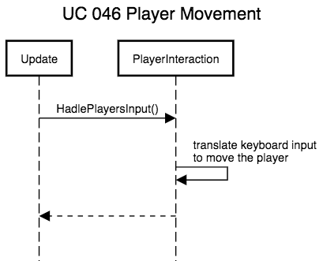

**UC 047—** **Player Crouching**

**Read keyboard input to have the player crouch**  
Inside Player Interaction’s Handle Players Input function, Lower the players height and slow the player movement.

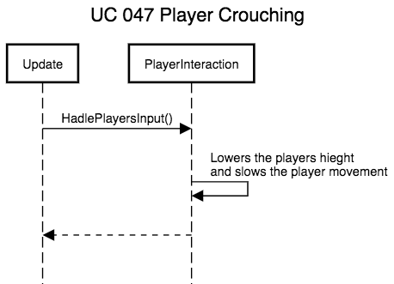

**UC 048—Player jumping**

**Read keyboard input to have the player jump**  
Inside Player Interaction’s Handle Players Input function, add upwards velocity to the player

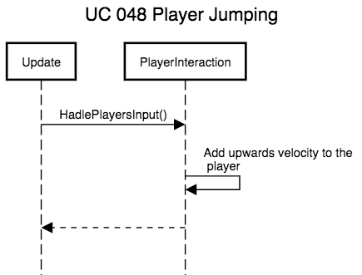

**UC 049—** **Climbing objects**

**Climb Ladders and ropes 049.1**

**Climbing over objects 049.2**

**Jump off of objects 049.3**

**UC 049.1—Climb Ladders and ropes**

**Player has right clicking on a ladder or rope**

Inside Player Interaction’s Handle Players Input function

Send out a ray cast to get the distance to the rope or ladder

Check to see if we are within arms reach

Move player to the nearest location on the rope or ladder

**Read keyboard input to move the player up or down**

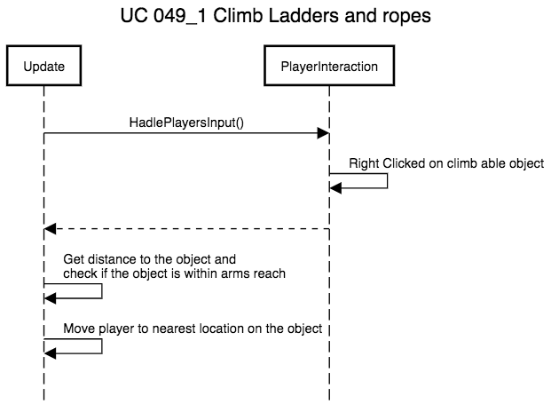

**UC 049.2—Climbing over objects**

**Player has right clicking on an object to climb over**

Inside Player Interaction’s Handle Players Input function

Send out a ray cast to get the distance to a climbable object

Check to see if we are within arms reach

**Move the Player**

Move the player up and over the object

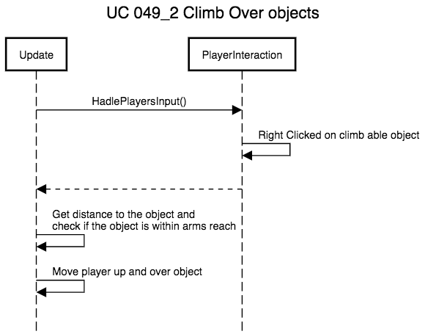

**UC 049.3—Jump off of objects**

**Read keyboard input to jump off the object**

Read keyboard input inside Player Interaction’s Handle Players Input function

**Move the Player**

Move the player up and away from the object

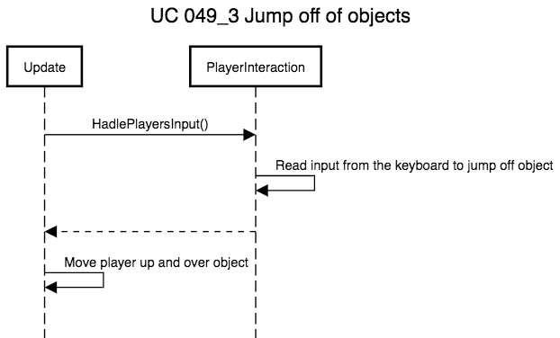

**UC 050—** **Player inventory**

**Reads keyboard input to look through inventory**  
Read input inside Player Interaction’s Handle Players Input function and move through the inventory one object at a time through a list of objects from the player inventory class.

**Reads keyboard input to toggle inventory**  
Read input inside Player Interaction’s Handle Players Input function and toggles whether or not the player can see and use the current item in the inventory.

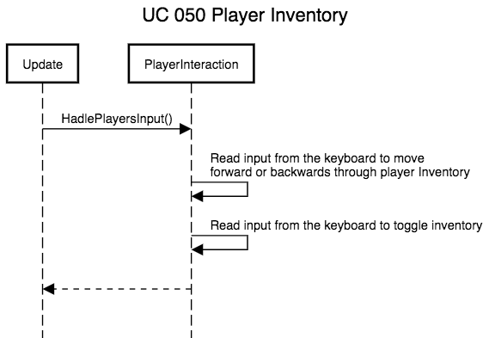

**UC 052—** **Opening doors**

**With in arms reach of a door**  
Inside Player Interaction’s In Range Of Intractable function, check if the player is within a certain distance to the door

**Read input from keyboard to open or close door**

Read keyboard input inside Player Interaction’s Handle Players Input function

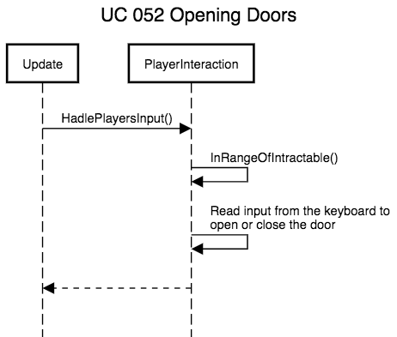

**UC 054—** **Picking Locks**

**In reach of a lock**

Inside Player Interaction’s in Range of Intractable function, check if the player is within a certain distance to the lock

**Player right clicks on the lock**

Read input inside Player Interaction’s Handle Players Input function

**Read keyboard input from player to pick the lock (See 2.c.i)**

Read keyboard input inside Player Interaction’s Handle Players Input function

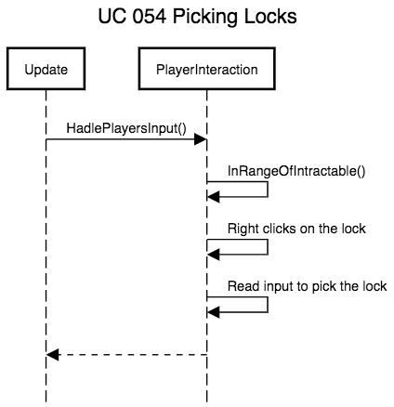

**UC 056—** **Pick safes**

**In reach of a safe**

Inside Player Interaction’s in Range of Intractable function, check if the player is within a certain distance to the safe

**Player right clicks on the safe**

Read input inside Player Interaction’s Handle Players Input function

**Read keyboard input from player to pick the lock (See 2.c.ii)**

Read keyboard input inside Player Interaction’s Handle Players Input function

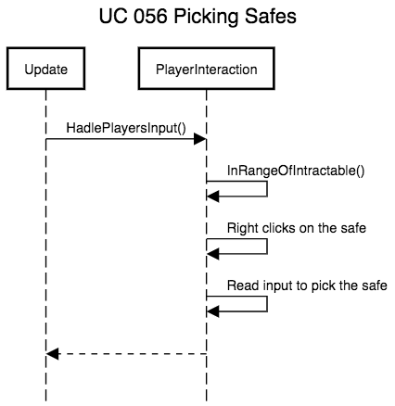

**UC 058—** **Stealing objects**

**Within arms reach of steal able objects**

Inside Player Interaction’s in Range of Intractable function, check if the player is within a certain distance to the stealable object

**The player right clicks on the object**

Read input inside Player Interaction’s Handle Players Input function

**Add the object to the players Inventory**

Adds the item to the player’s inventory class

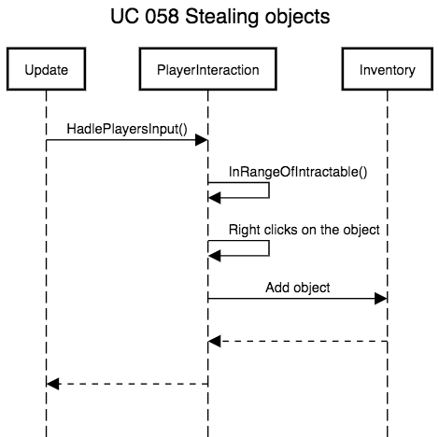

**UC 060—** **Knocking out enemies**

**In arms reach to an enemy**

Inside Player Interaction’s In Range Of Enemy function, check if the player is within a certain distance to the enemy

**Player left click on enemy**

Read input inside Player Interaction’s Handle Players Input function

**The enemy is not in an alerted state**

Get enemy’s state from the enemy brain class

**Knock an enemy out**

Call hit enemy from enemy damager class

Set an enemy knockout state in enemy brain class

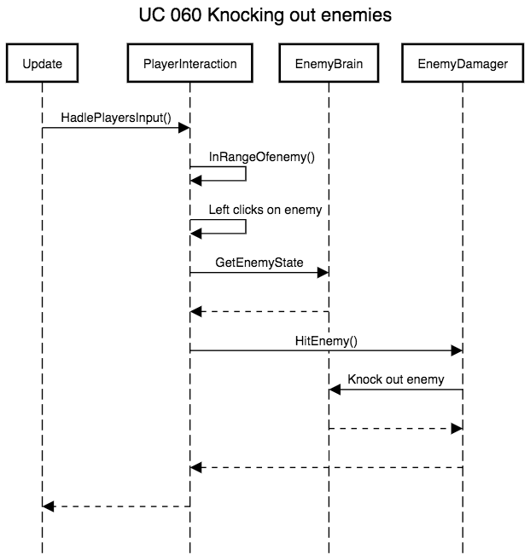

**UC 062—** **Putting out light sources**

**In reach of an extinguishable light**

Inside Player Interaction’s In Range Of Intractable function, check if the player is within a certain distance to the light

**Player right clicks on the light**

Read input inside Player Interaction’s Handle Players Input function, send out a ray cast to the light, get the light’s light component

**Put out the light source**

Deactivate the light component

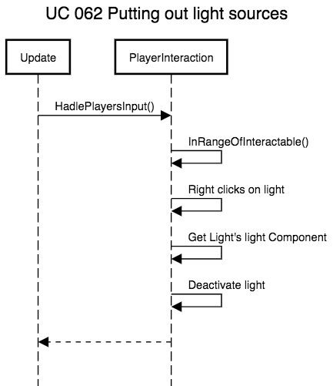

**UC 064—** **Using switches**

**In reach of switch**

Inside Player Interaction’s In Range Of Intractable function, check if the player is within a certain distance to the switch

**Player right clicks on the switch**

Read keyboard input inside Player Interaction’s Handle Players Input function, send out a ray cast to the light, get the switch’s component

**The switch will activate or toggle something in a level**

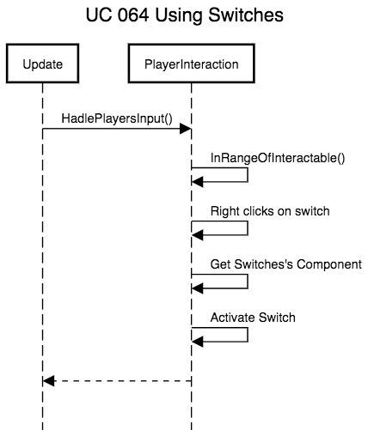

**UC 065—** **Enemy AI**

**Enemy Movement, Navigation, and Interaction**

**Shadow Detection**

**Sound Detection**

**Enemy Detection**

**UC 080—** **Level**

**The information need for a level**

**UC 085—** **Database**

**Connecting to the database to send and receive data**

**Close connection when done**

**UC 090—** **Hosting the game**

**Player Start to load the game**

**Connects to the sever to download the game**

Once downloaded the game will start playing in the browser